**1.INTRODUCTION**

**1.1 OVERVIEW**

The "BISMI CHICKEN STALL" WordPress blog project aimed to create an online platform for Bismi Chicken Stall, a local food business. The objective was to establish an engaging and informative digital space that showcases the stall's menu, specialties, recipes, customer experiences, and food-related content. The primary goal was to increase the stall's online presence, attracting more customers and engaging the existing customer base

**1.2 PURPOSE OF THE PROJECT**

* The primary objective of the "BISMI CHICKEN STALL" WordPress blog project was to establish a dynamic online presence for the local food business, aiming to achieve the following:
* Enhance Online Visibility: To increase the stall's visibility and accessibility for a wider audience, catering to both existing and potential customers.
* Engage and Inform: To create an engaging digital space where visitors could explore the stall's menu, discover recipes, and engage with diverse content, fostering a sense of community.
* Brand Representation: To accurately represent the unique identity, ambiance, and offerings of Bismi Chicken Stall through the blog's design and content.

**RESULT**

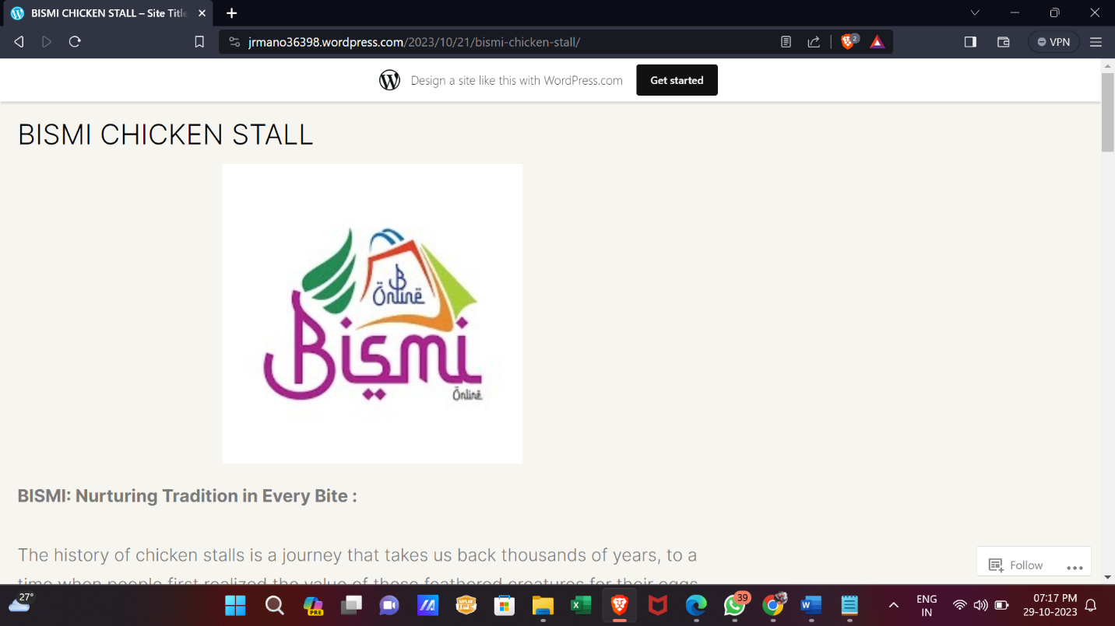

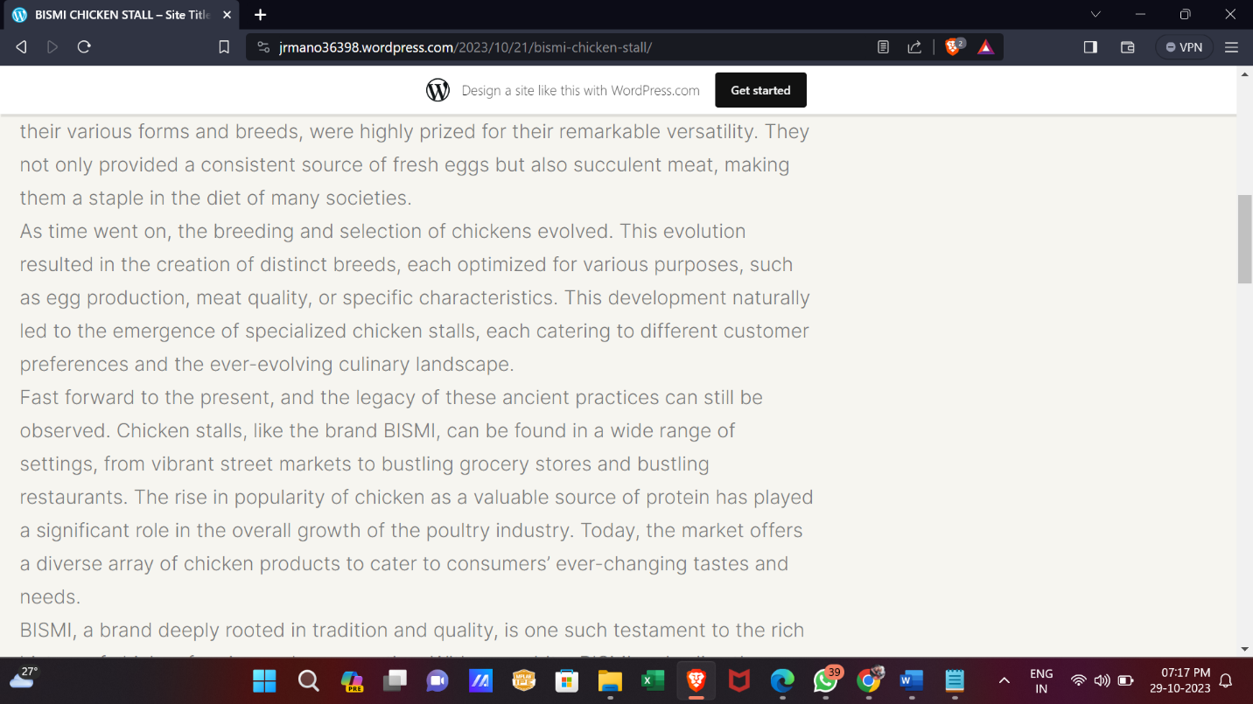

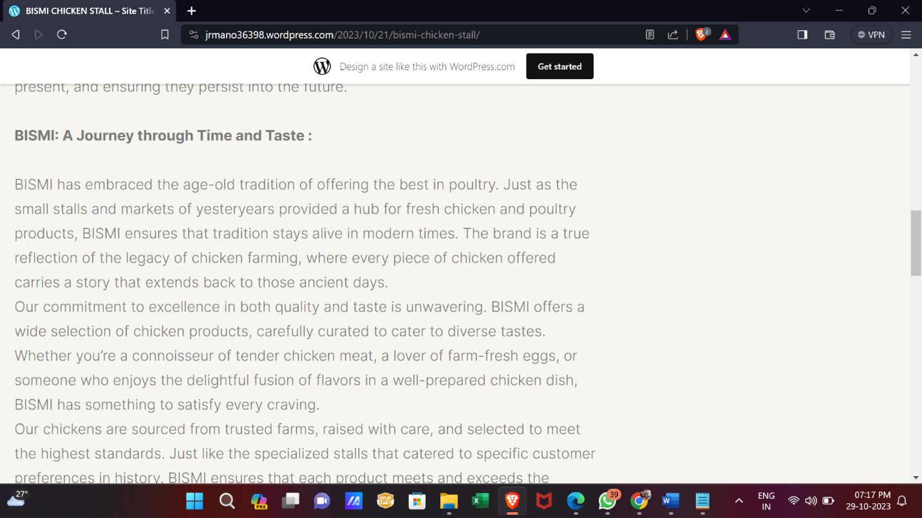

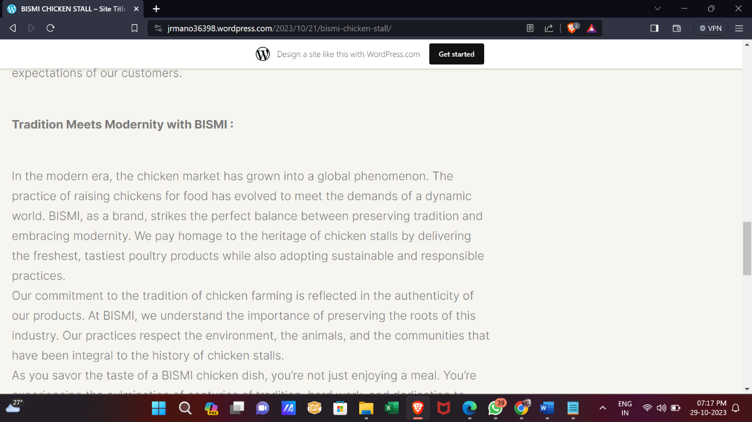

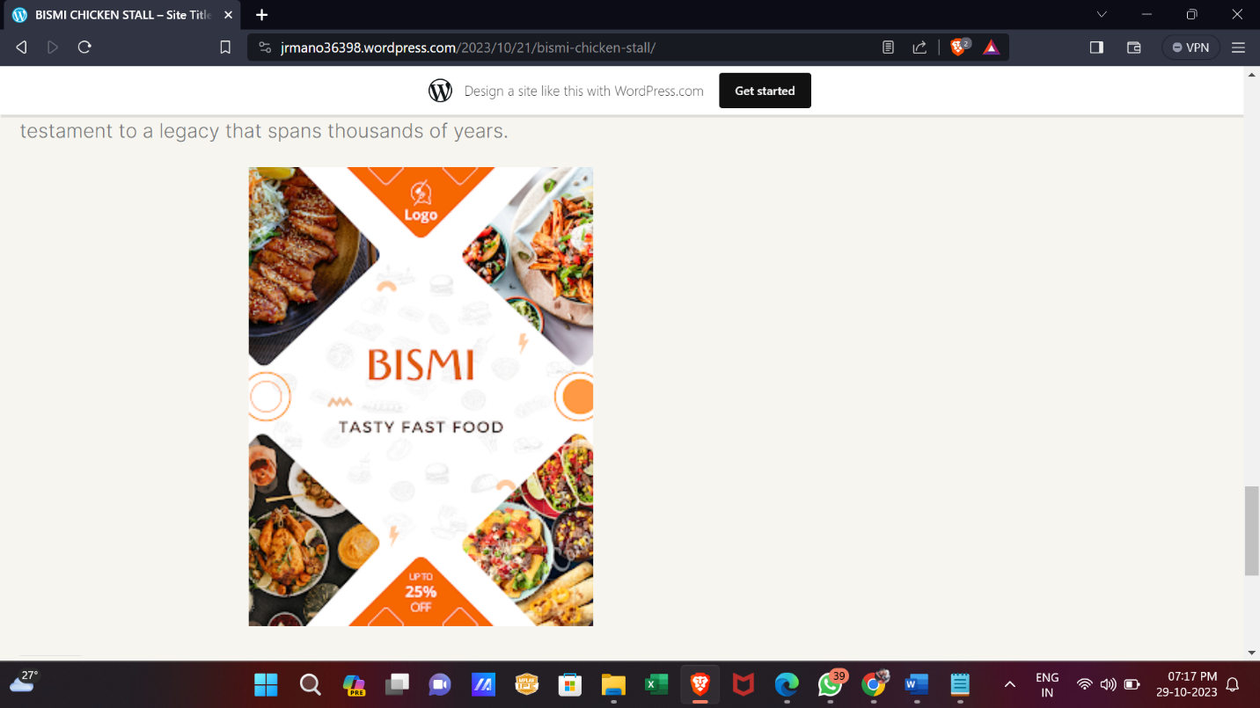

**Advantages:**

1. Increased Online Visibility:- The blog provided an online platform for the "BISMI CHICKEN STALL," enhancing its visibility and accessibility to a broader audience beyond the local customer base.

2. Engagement and Interaction:- Enabled direct interaction with customers through comment sections, fostering engagement, feedback, and a sense of community.

3. Brand Promotion:- Effectively promoted the brand by showcasing its offerings, unique selling points, and customer reviews, creating a positive image among potential customers.

4.Content Marketing:- Acted as a hub for valuable content, including recipes, menu updates, and customer testimonials, attracting visitors seeking information about the stall's offerings.

5. SEO Benefits:- Improved search engine visibility through SEO strategies, potentially driving organic traffic to the blog and subsequently to the stall.

6. Cost-Effective Marketing:- Provided a cost-effective marketing channel compared to traditional advertising methods, catering to a tech-savvy audience.

**Disadvantages:**

1. Maintenance Effort:- Requires consistent effort in updating content, monitoring comments, and ensuring the blog remains active and relevant, which could be time-consuming.

2. Technical Challenges: - Technical issues like plugin updates, security concerns, or unexpected errors might arise, demanding technical expertise or resources for troubleshooting.

3. Competitive Online Space:- Operating in a competitive online space, standing out among numerous food blogs and competitors required continuous innovation and unique strategies.

4. Limited Local Impact:- While it expanded the reach beyond the local area, the blog might not have had a significant impact on local foot traffic to the stall.

5. Dependency on Online Reputation: - Relies heavily on maintaining a positive online reputation, as negative reviews or lack of timely responses to comments can impact the stall's image.

6. Measurement of ROI:- Determining the Return on Investment (ROI) from the blog in terms of increased sales or footfall might be challenging, making it difficult to quantify its success directly.

**APPLICATIONS**

1. **Content Integration:**

Incorporate blog content, including recipes, customer reviews, menu updates, and featured posts within the app for easy access and engagement.

1. **User Engagement Features:**

Implement user accounts, push notifications for new content, and social media integration, allowing users to interact, save favorite recipes, and share content.

1. **Continuous Improvement and Marketing:**

Commit to regular updates for improved features, security, and user experience. Utilize marketing strategies to promote the app and encourage downloads among the existing blog audience for enhanced engagement.

1. **Mobile Access:**

Develop a mobile application for iOS and Android platforms to extend the reach and accessibility of the blog beyond the web platform, catering to a larger audience.

**CONCLUSION**

The creation of the "BISMI CHICKEN STALL" WordPress blog marked a significant milestone in extending the stall's presence beyond its local reach. The project aimed to leverage the digital platform to promote the stall's offerings, engage with customers, and create an online community centered around our brand. Through this endeavor, several key points emerged, outlining both successes and areas for potential growth.